# EcfFilenetServices & HHSSystemServices

# Branching & Release Instructions

Contents

EcfFilenetServices & HHSSystemServices 1

Branching & Release Instructions 1

Diagram 3

End of each Sprint 4

1) Merge the current DEV line into Master line 4

2) Verify master has merged correctly 4

3) Create new Dev Branch 4

4) Add policy to new DEV Branch 4

5) Delete Previous sprints DEV line 6

6) Create new local branch based on new DEV line 6

7) Email Notification 6

8) Follow Production Release steps 6

Production Release 7

1) Verify that everything for release is delivered to the current DEV line. 7

2) Build Process 7

3) Create folder named for the release version 7

4) Place builds in this new folder 7

5) Compare each jar file 7

6) Create Production Release Tag 7

7) Create new Production Branch 8

8) Delete Previous PROD line 8

9) Update POM files 8

HotFix 10

1) Create New Defect/Personal Branch 10

2) Pull Request 10

3) Update Master 10

4) Update Dev line 10

## Diagram

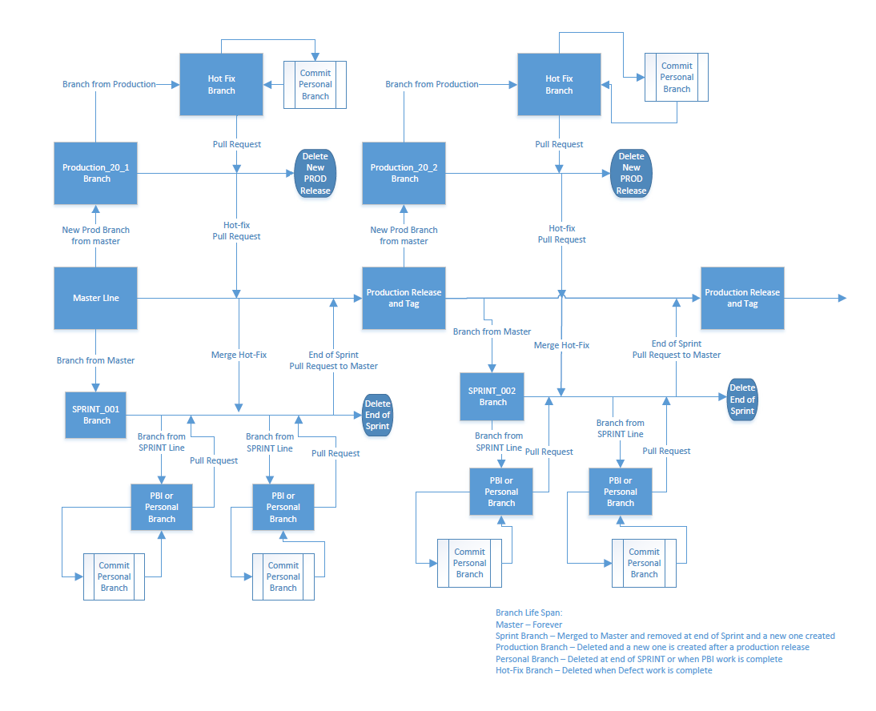

## End of each Sprint

### Merge the current DEV line into Master line

Create new Pull Request

Make sure Dev line into Master is chosen.

Note the dev line will be named DEV_<sprint> example: DEV_2020S13

Title: “End of Sprint <sprint name>” example “End of Sprint 2020S12”

Clear all work items

Create and complete as normal

### Verify master has merged correctly

by looking for a known new or update file or by clicking on branches, development

should be 1 behind and 0 ahead

### Create new Dev Branch

Create New Branch

Name: DEV_<sprint> example DEV_2020S13

Based On: Master

### Add policy to new DEV Branch

Open new dev branch

Scroll down to Build Validation and click on plus button

Add Build policy

Build pipeline: choose ‘EcfFilenetServices DEV Commit’ for EcfFilenetServices project

choose ‘HHS System Server DEV commit” for HHSSystemServices project

Build Expiration: change to 1 hours

Display name: Run Unit tests

Click Save

Example screen shot from EcfFilenetServices:

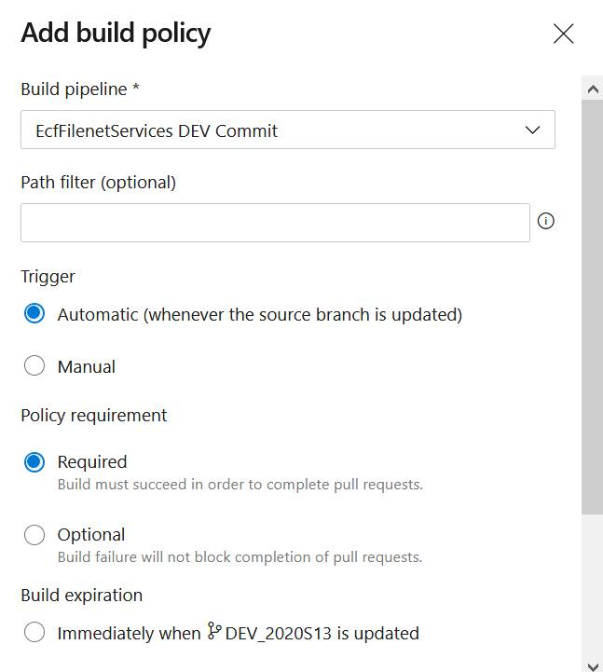

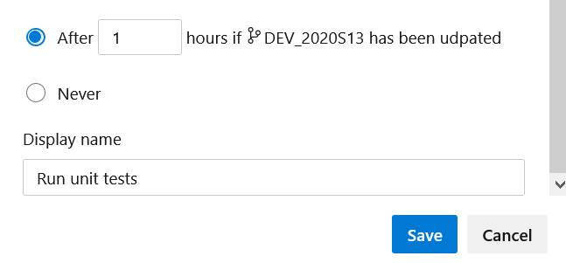

### Delete Previous sprints DEV line

Until we get comfortable, we should keep the old DEV line after a master merge for a few days

as a backup for a while.

### Create new local branch based on new DEV line

Team -> Remote -> Fetch From so local git knows about new branches and tags

Create new local branch

Check it out blah blah

Delete old branch

Note: If you are working ahead and cannot deliver all of your code before these steps are done then pull from new dev line into your local branch before push up into new dev line from your local branch before creating the new branch from new sprint’s dev line.

## Email Notification

Send email out to service team letting them know this is done. Email should contain name of new DEV branch.

## Follow Production Release steps

ONLY if end of sprint is also a production release

## Production Release

### Verify that everything for release is delivered to the current DEV line.

Ask team members if everything is delivered.

### 

### Build Process

Build Dev, QA, Staging and Production jars. These are our production candidate builds.

### Create folder named for the release version

Create new folder name in this location. The folder will be named for the release.

T:\HSPH Restricted Access Workspace\Ecf L3 Production Support\Ecf_Deployments\ECF Next\<release name>

Example release name 20_1

### Place builds in this new folder

Place each projects jar files into its own folder under the new folder created in previous step.

Note: our deployment documentation will be in this new folder too

### Compare each jar file

Using Beyond Compare to make sure the differences in jar files are correct for the environment.

### Create Production Release Tag

Go to Tags

Click New Tag

Name: <release name> example: 20_1

Based On: Master

Description: <release name> production release

### Create new Production Branch

Create New Branch

Name: PROD_<release name> example PROD_20_1

Based On: Master

### Delete Previous PROD line

### Update POM files

In the new DEV line update project pom files. You are updating the version in 2 pom files and 3 locations.

1. Update project version in project

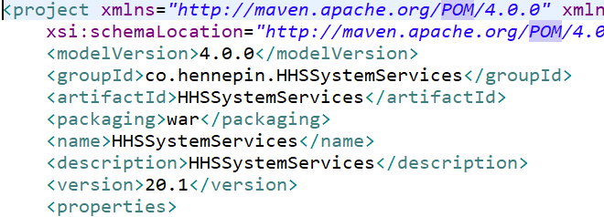

1. Update project version in EAR project

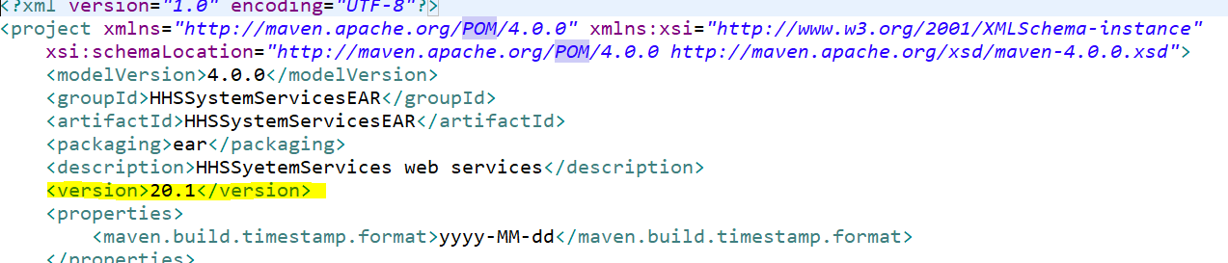

1. Update dependency version in EAR project

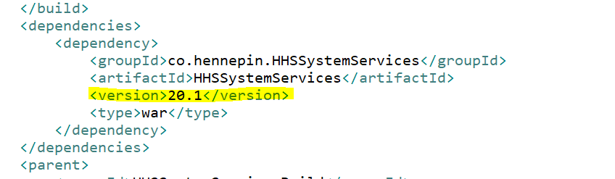

## HotFix

## Create New Defect/Personal Branch

Based On: PROD_<release name> example PROD_20_1

## Pull Request

Create a pull request from new Defect/Personal Branch to PROD branch

## Update Master

Create pull request from PROD to Master

## Update Dev line

Create pull request from Master to DEV Sprint line